Babble Chat

Requirements Document
Table of Contents
1 Introduction 3
1.1 Purpose and Scope 3
1.2 Target Audience 4
1.3 Terms and Definitions 4
2 Product Overview 5
2.1 Users and Stakeholders 5
2.1.1 Alice, Stakeholder 5
2.1.2 Marco and Polo, Users 6
2.2 Use cases 6
2.2.1 Server Access 7
2.2.2 Account Creation 7
2.2.3 Access User and Chat History 7
2.2.4 Chatting 7
2.2.5 Logging Out 8
3 Functional Requirements 9
3.1 Unique Babble Account 9
3.1.1 Registration Tool 9
3.1.2 Log-in with Password Verification 9
3.1.3 Logging-out 9
3.2 Chat Interface 9
3.2.1 Friends List 9
3.2.2 Message Box 10
3.2.3 Chat Box and History 10
3.3 Chat Servers 10
4 Nonfunctional Requirements 11
4.1 Real-Time Communication 11
4.2 Performance 11
4.3 Security 11
4.4 Scalability 11
5 Milestones and Deliverables 12
5.1 Requirements Document (April 25th) 12
5.1.1 Revision (Ongoing) 12
5.2 Analaysis 13
5.2 Design (May 9th) 13
5.3 Test Plan (May 30th) 13
5.3 Implementation 13
5.4 Project Report and Final Deliverables (June 8th) 13

Introduction
This section introduces the Babble chat application and an overview of what the client expects, what the users will want to make this a successful project.

Purpose and Scope
The purpose of this document is to identify client and user needs to build an effective chat environment that both client and user(s) can use on a regular basis to enhance communication across the internet. The document will detail the various use cases that should be considered, as well as functional and nonfunctional requirements. It will conclude with milestones and deliverables to successfully create a product per the client specifications and user(s) needs.

This document will be open to revision as the project progresses, but this version should encompass the user’s need and the big-picture of what the client expects.

The scope of Babble chat includes the following features:
- Set-up and create a successful network over which users can connect and send communications.
- Create a user interface that is intuitive to use in terms of creating an account, selecting a recipient to message, looking at chat history, and logging-out.
- The data should be easy to manage and store unique user ids, passwords in a form that can be verified and chat history for the main user with various other users.
- Unique accounts should only be accessible after user identity verification, otherwise, it should be protected.

Target Audience
Users who want a simple chat interface to communicate for work or personal use.

Terms and Definitions
Definitions of frequently used and helpful terms, acronyms and/or abbreviations:

Term |  | Definition
Babble |  | The name of the chat application
Java |  | The programming language that will be used to build the chat
GUI |  | Graphical User Interface
Netty.io |  | A client-serer framework for setting up a server (or servers)
Network socket (aka socket) |  | “an internal endpoint for sending or receiving data at a single node in a computer network” (Wikipedia: Network Socket)
User/Client |  | An individual who is or will be using the chat system
Stakeholder |  | The person who has an invested stake in the success of the chat application
Use Case |  | Example scenarios of how user(s) may need to use the application

Product Overview
This section will give a broad overview of the Babble chat application’s functionality.

The user(s) is the person or persons using the chat application, and the stakeholders is the individual funding the project. As there are no funds supporting this development, therefore, the stakeholder’s stakes ride on the success of the application.

To get the project going, a chat server with the ability to scale must be created. Using the created servers, clients should be able to send and receive messages in a chat environment (a reasonable GUI) in real-time. Each user will have a unique identity (username) and password to access the chat environment. Using this service will require registration. Once logged-in, the user should be able to see other users (as they log-on and log-off) and be able to chat by selecting the person.

The main goal of this project is to have a simple, working application with an intuitive interface. There will be no fancy additions to the chat environment unless extra time allows.

Users and Stakeholders
This section describes client, Alice W., whose main concern is the successful functionality of the chat application. Two fictive users, Marco and Polo, will also be referred to further explain use cases of the chat application.

Alice, Stakeholder
Alice brainstormed the idea of Babble thinking that currently existing chat networks are sorely lacking. She expects a functioning chat system that is quite simple and initially allows two users to chat. Note: she is a fictional character for the sake of making this document a bit more interesting and realistic. While she is an actor behind the scenes, she does not take part in the use cases because those focus around the users for this particular chat application.

Marco and Polo, Users
Marco and Polo represent two users who are using the application post-implementation, but who have given feedback on what they want from a chat application that would sweep them away from Facebook and other so-so chat options that are out today. Note: they are fictive characters and their names are, indeed, quite intentional.

Use cases
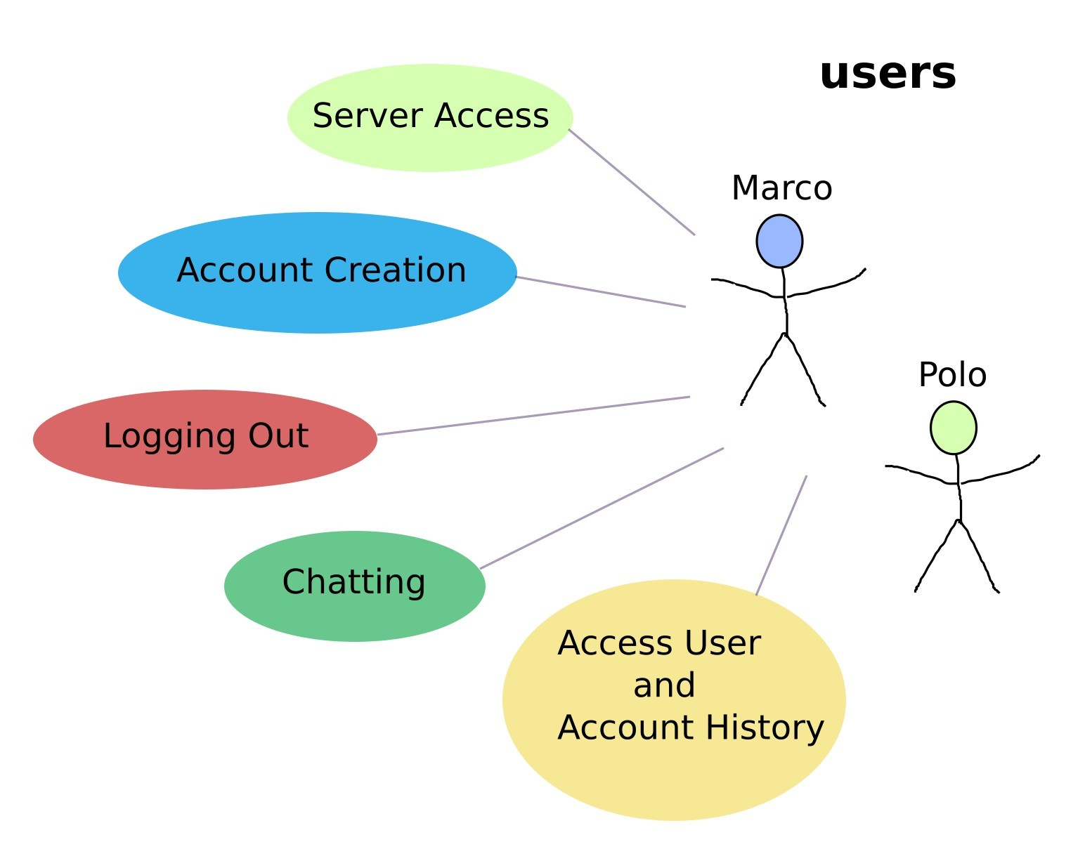
The following are use cases involving the users, mentioned earlier, and likely interactions using the chat application.

Server Access
Assuming they have a reliable internet connection, Marco and Polo should be able to access the server on which they should see a GUI on which they can log-in to their individual accounts.

Account Creation
Users should be able to register with a unique name and a password. Upon successful registration they should be able to log-in and log-out from their account.

If an invalid username (having symbols or already taken by another user) is attempted, they should see the correlating error to let them know why the username is invalid. For example, if Marco makes the username marcopolo, he will be known as marcopolo from there on out. If Polo later tries to make the same name marcopolo, he will encounter the message, “Please choose a different name. This one has already been taken.”

If users enter an invalid password when trying to log-in, they should similarly get an error message saying the password is incorrect with a limited number of attempts to log-in. If Marco’s password is “password” and he enters “asdfasdf”, then he will see the error message, “Incorrect password. Please try again.”

Access User and Chat History
Users information should be stored behind the scenes so that their identity can be validated and they can access their personal account. These records should also hold chat history so users can access these records.

Chatting
Users should be able to see other users when they are logged-in and be able to select a specific user. After another user is selected a history of chats should pop-up if they have chatted previously. Regardless of whether this is a new or old communication, the initial user should be able to start a new communication by sending and receiving messages.

Logging Out
Users should be able to log-out with an easily usable user interface. Logging-out should prevent anybody else from accessing the account without the valid username and password, thereby protecting the user’s personal account details.

Functional Requirements
A functional requirement is a feature that is required for the chat network to work. The following section will detail essential features that will be implemented.

Unique Babble Account
The user will be able to register and create a unique account using a clean graphical interface.

Registration Tool
A user should be able to make an account with a unique username (try again if their username has already been taken). To finalize this process, they should be able to create a password which they will later use to re-access their account.

Log-in with Password Verification
A user should be able to log-in with their username and only get access when their password has been verified.

Log-out
A user should be able to log-out when they are done with their session.

Chat Interface
There should be an intuitive interface where the user can select a person to chat with and quickly send a message to them, seeing the sent message, and be able to receive a message as well.

Friends List
User should see list of friends that they can select to initiate a chat session. Friends who are logged-in and logged-off will be graphically differentiated.

Message Box
The message box should be easy to see and access. After selecting a friend, a user should be able to send a message using the message box and Send Button or Enter Key.

Chat Box and History
When selecting a friend, the unique chat history with the friend should appear above the message box. If there is no history, this box will be blank.

Chat Servers
A user must be able to communicate through the server after logging-in with verified credentials. Servers must be able to scale with a large amount of users to potentially allow for group chatting sessions as well. At this time, there is still debate as to whether Netty.io or the java.net package will likely be used to set-up the servers and network sockets so users can connect. While the java.net package would be very quick and easy to set-up, using netty.io will likely make the application more scalable.

Nonfunctional Requirements
Nonfunctional requirements can include further constraints that are not bound by the chat software itself.

Real-Time Communication
The software should run quickly enough that messages sent through servers should be read immediately after they are sent.

Security
Users should only get access to an account if they have the correct username and password. A logged-out session should ensure that the account details are no longer accessible until the user logs back in.

Performance
Babble chat should, at a very simple level, allow the users Marco and Polo to send and receive messages from one another. If so, scalability may be the next focus.

Scalability
While the chat will begin with a small number of users, the goal is that it can scale up to hundreds if not even more. It should be implemented so that scalability is not an issue.

Milestones and Deliverables
This section outlines the promised deadlines for the deliverables such as this document (an overview of the client’s needs), testing and implementation, and post-delivery maintenance. It contains additional sections on analysis and implementation with no concrete deadlines listed, but they will fall within the start and end dates of this project as detailed below in the timeline. While revisions may be made to this document, if extensive revision is required, the milestones and deliverables may need to be renegotiated to keep a realistic time line.

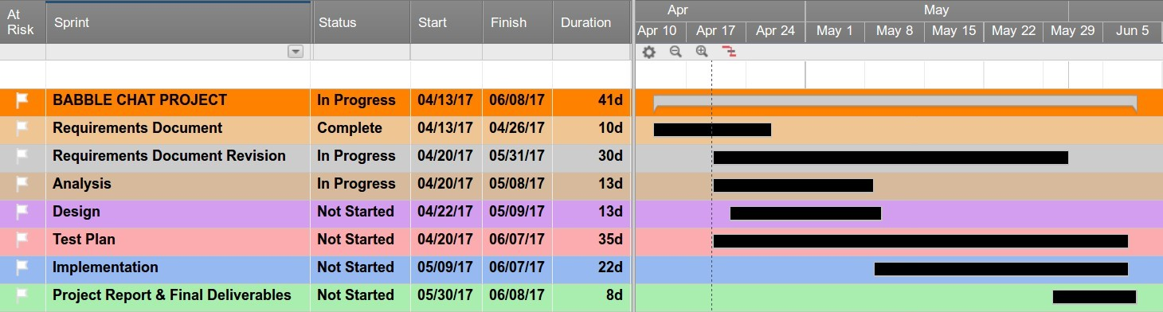
If the project proceeds as outlined in this document, the work flow should progress as drawn in this Gantt Timeline:

Requirements Document (April 25th)
This document contains a well-researched overview of the client’s needs to create a successful Babble chat application.

Revision (Ongoing)
Revisions to the Requirement Document may occur if the client thinks of other essential components the chat may need, but substantial change in planning may affect the milestones and deliverables deadlines.

Analysis
The details outlined in the requirements document will be further refined to further specify use cases, whether Netty.io or java.net sockets may be used, whether external files or a database may be used to hold user data, and so forth.

Design (May 9th)
An overall UML design of how the application will be implemented in an object-oriented fashion.

Test Plan (May 30th)
After thorough analysis, tests should be planned to avoid unnecessary hiccups down the line. If these are well-planned, the maintenance of the application should also be much easier.

Implementation
This phase will incorporate continued testing while implementing the actual chat application.

Project Report and Final Deliverables (June 8th)
The project report will encompass the project and be presented alongside the final deliverables, the chat application, which will be demonstrated as fulfilling the expectations set out in this Requirements document on behalf of the client’s needs.

